Step 1:-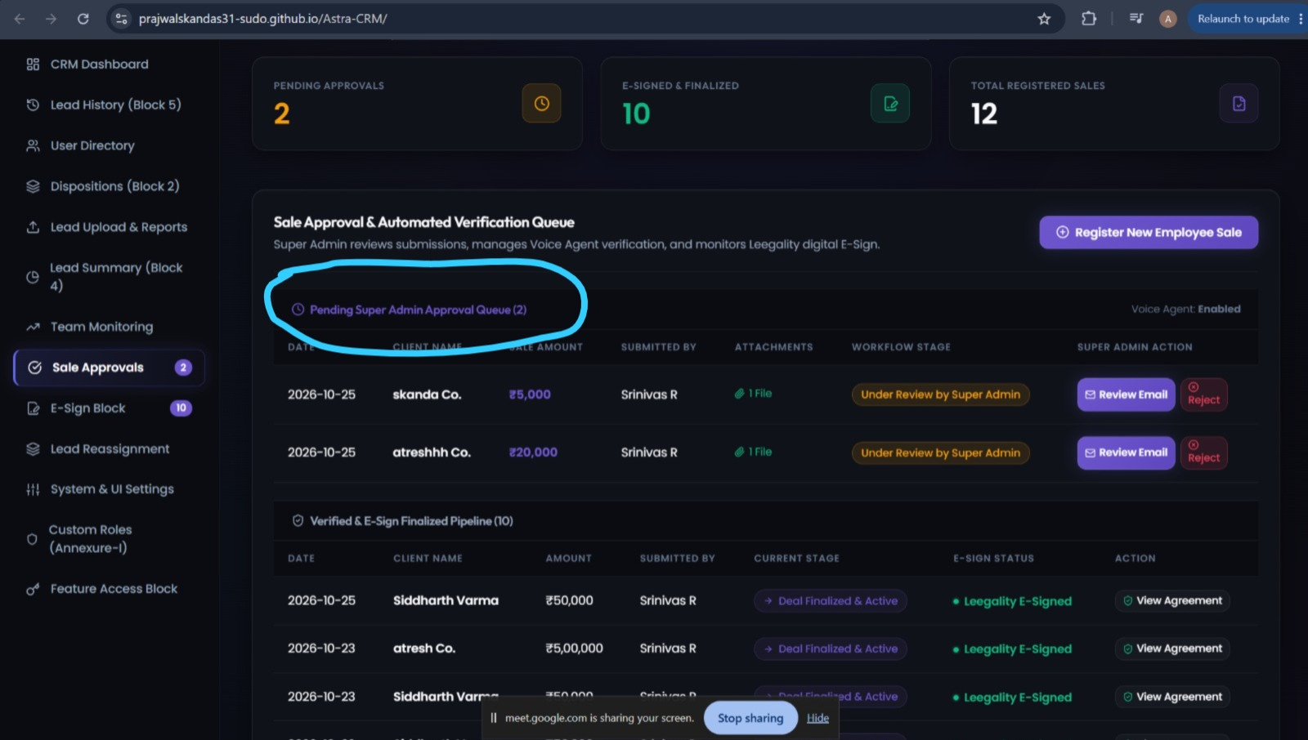
give provision to trigger e kyc and e sign process
Step 2:-
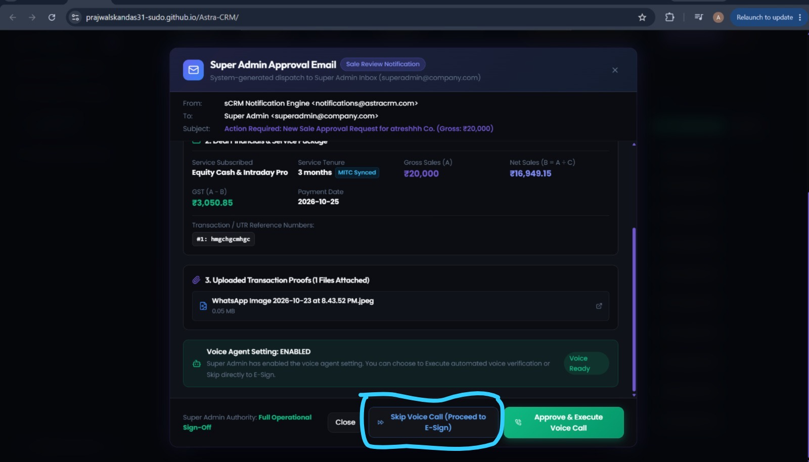
when clicked on "skip Voice call" , remove the simulation and replace with the actual process in leegality by using the given api details, work flow id- LzfDhWc, and the template id that is already given, to your requirement and referece.

